**Lesson 1 Demo 3**

**Working with List**



Steps to be followed:

* Add the application to visual studio and create an index.html file
* Create and work with the list

**Step 1: Add the application to visual studio and create an index.html file**

* 1. Open a directory   
        
     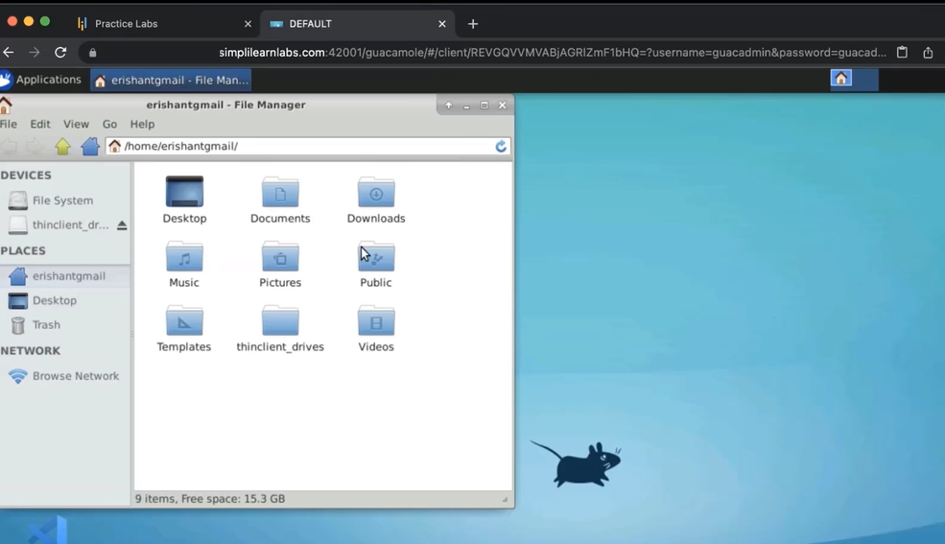
  2. Open my documents  
       
     Graphical user interface, application

     Description automatically generated
  3. Create a new folder as MyWebApp  
       
     Graphical user interface, application

     Description automatically generated
  4. Open the visual studio code  
       
     A screenshot of a computer

     Description automatically generated with medium confidence
  5. Drag and drop the MyWebApp in the visual studio  
       
     Graphical user interface, text

     Description automatically generated
  6. Create file name **index.html**  
     Graphical user interface, text

     Description automatically generated
  7. Enter **Doctype**, create an HTML tag, and inside it, create a body tag  
       
     Application

     Description automatically generated with low confidence
  8. Create an H3 tag as **Welcome to My App**  
       
     Graphical user interface, text, application

     Description automatically generated
  9. Come back to the documents folder, click on the **index.html** file  
       
     Graphical user interface, text, application

     Description automatically generated
  10. Open the file with google chrome  
        
      Graphical user interface, text

      Description automatically generated

**Step 2: Create and work with list**

2.1 In the visual studio code, inside the body, write a tag, type ul, and select ul from the dropdown. To create a list enter li and select list from the dropdown  
  
* 1. Enter **home** inside li. Create a few more li’s. Enter About, Products, Profile, and Contact in it  
       
     Text, application

     Description automatically generated
  2. Open Chrome and refresh the page  
       
     Graphical user interface, text, application, email

     Description automatically generated
  3. Update the values in the list and then save the file.  
       
     Text

     Description automatically generated with medium confidence
  4. Go to Chrome and refresh it  
       
     Graphical user interface, text, application, email

     Description automatically generated
  5. Go to the visual studio code and change the list to the ul  
       
     Text, application

     Description automatically generated
  6. Add the head tag and add a style tag inside it  
       
     Graphical user interface, text, application

     Description automatically generated
  7. Enter ul, Inside it, create an object as **list-style-type:none;** and save it  
       
     Graphical user interface

     Description automatically generated with medium confidence
  8. Go to Chrome and refresh it  
       
     Graphical user interface, text, application

     Description automatically generated
  9. Go to the visual studio code. Create another style for the list with **li{ float: left }** and save it  
       
     Shape

     Description automatically generated with medium confidence
  10. Go to Chrome and refresh it  
        
      Graphical user interface, text, application, email

      Description automatically generated
  11. Add gaps/margins in the text element. Enter **margin-right:8px;** and save it  
        
      Graphical user interface, application

      Description automatically generated
  12. Go to Chrome and refresh it  
        
      Graphical user interface, text, application

      Description automatically generated
  13. In the visual studio, create multiple web pages. Create new files as **home.html**, **contact.html**, **about.html**, **product.html**, and **profile.html**  
      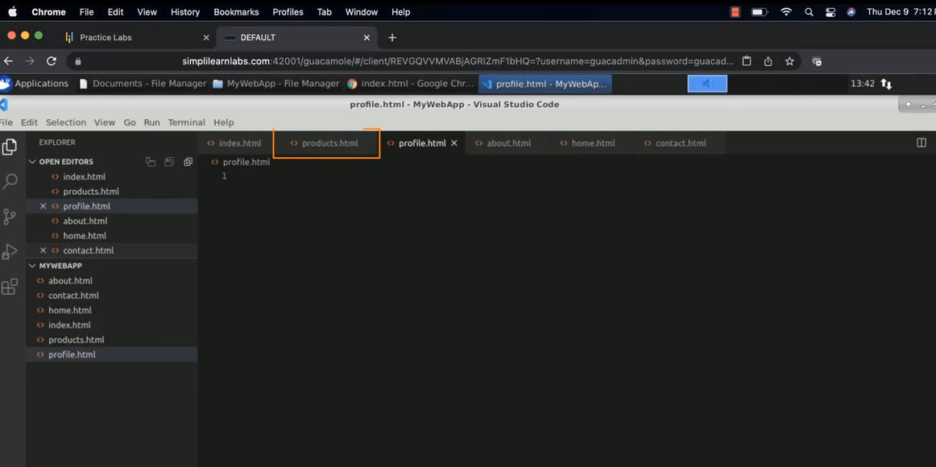
  14. In the Product.html file, enter Doctype. Create an HTML tag, and inside it, create a body tag in all html files, create an H3 tag inside the body tag. Enter **Welcome to Products**. Copy the content. Paste it into other HTML files. Change the H3 sentence according to the file name.

* 1. Remove the **home.html**. Consider index.html as your home page  
       
     Graphical user interface, text

     Description automatically generated
  2. Go to the index.html, surround all the attributes inside the anchor tag i.e <a>  
       
     Text

     Description automatically generated
  3. Inside href, give the files according to the attributes. For e.g. <li>About</li> we can say it as ‘<li><a href=”about.html”>About</a></li>’. Do the same for other attributes. Save it.  
       
     Text

     Description automatically generated
  4. Go to Chrome and refresh it  
       
     Graphical user interface, text, application, email

     Description automatically generated
  5. Click on **About,** you will be directed to the about page  
       
       
     Graphical user interface, text, application, email

     Description automatically generated
  6. Go back and click on the **Product**, you will be directed to the product page  
       
     Graphical user interface, text, application, email

     Description automatically generated
  7. Go back and click on the **Profile**, you will be directed to the profile page  
       
     Graphical user interface, text, application, email

     Description automatically generated
  8. Go back and click on the **Contact**, you will be directed to the contact page  
       
     Graphical user interface, text, application, email

     Description automatically generated